**SHODAN.IO**

**NATIONMEDIA.COM**

IP ADDRESS 196.6.202.2

<https://www.shodan.io/host/196.6.202.2>

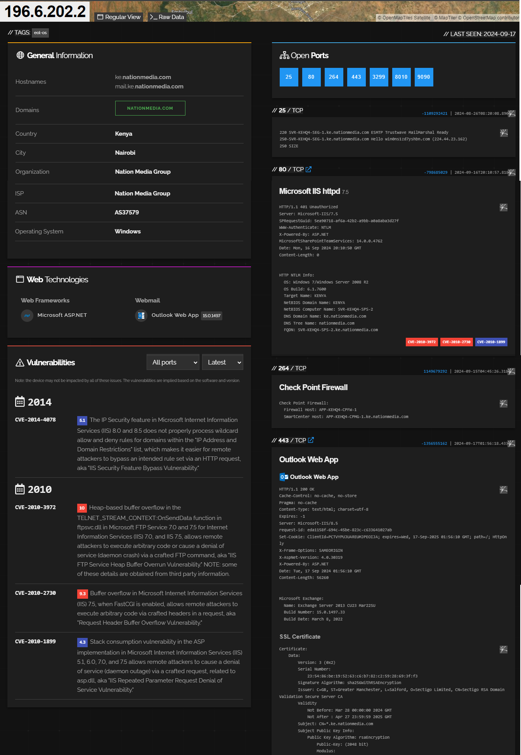

**JUDICIARY.GO.KE**

IP ADDRESS 196.216.82.44

<https://www.shodan.io/host/196.216.82.44>

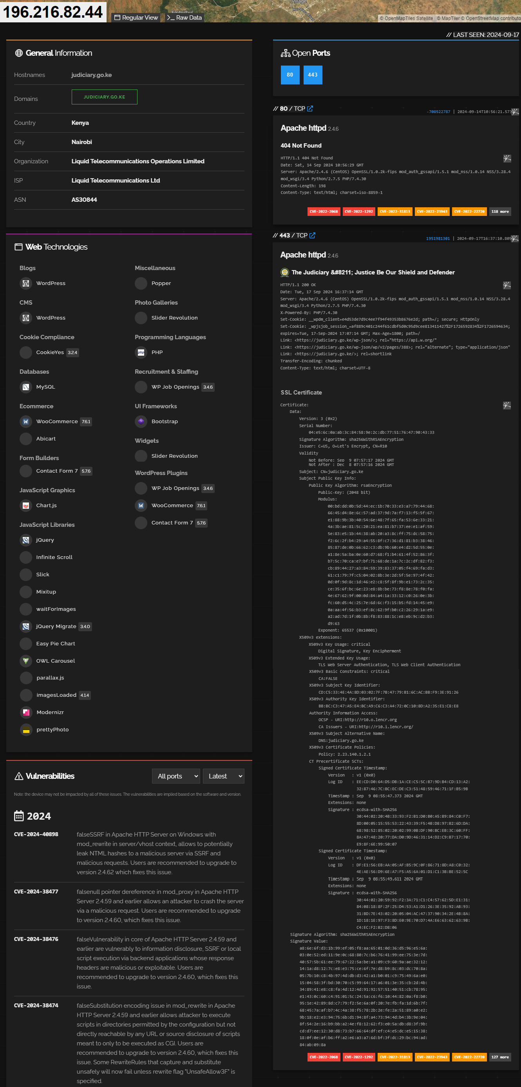

**BETIKA.COM**

IP ADDRESS 162.159.128.86

<https://www.shodan.io/host/162.159.128.86>

